**Lab 6: Data Manipulation Languages (DML)**

**Objectives:**

The objective of this task is to perform various SQL operations, including UNION queries, creating views, and joining tables, on a Northwind-derived database. The goal is to extract and analyze data from tables like customers, employees, products, and orders to gain insights such as customer lists and product details. Additionally, the task aims to enhance proficiency in creating views for simplifying complex queries and aggregating data.

1. **Data Import:**
2. **Download northwind-db.sql from classroom link**
3. **Open MySQL Workbench and Login using root or <name>**
4. **Create database <name>northwind**

**Query:**

CREATE DATABASE sulavlab5_northwind;

**Output:**

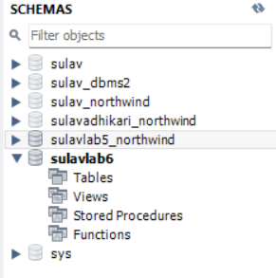

1. **Import downloaded database in sulavlab5_northwind**

**Output:**

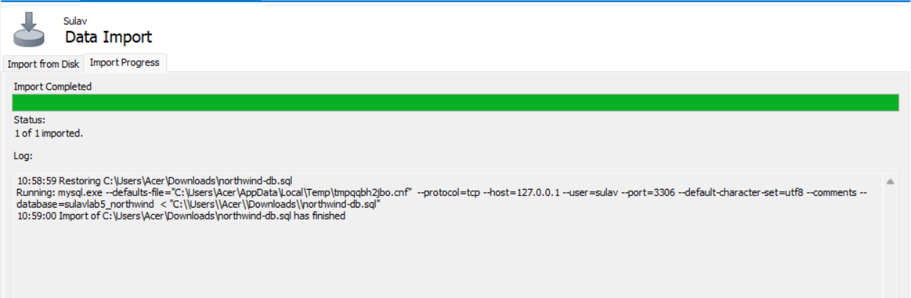

1. **Data Manipulation Languages (DML)**

**1. Perform UNION of customers and employee’s relation. (i.e. only matching attributes)**

**Query:**

SELECT CustomerName AS Name, ContactName AS Contact FROM customers

UNION

SELECT CONCAT(FirstName, ' ', LastName) AS Name, NULL AS Contact FROM employees;

**Output:**

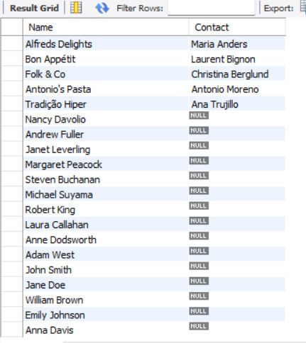

**2. Perform UNION ALL of customers.contactname and employee.fullname**

**Query:**

SELECT ContactName FROM customers

UNION ALL

SELECT CONCAT(FirstName, ' ', LastName) AS ContactName FROM employees;

**Output:**

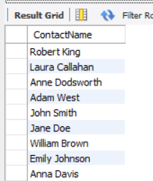

**3. List all customers from Berlin, Germany and**

**Query:**

SELECT * FROM customers WHERE City = 'Berlin' AND Country = 'Germany'

UNION

SELECT * FROM customers WHERE City = 'Paris' AND Country = 'France';

**Output:**

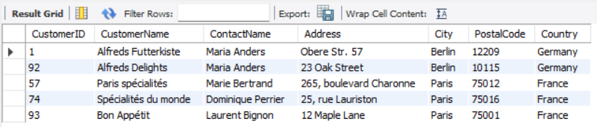

1. **List all customers of USA not having same name as of customers from UK**

**Query:**

SELECT * FROM customers

WHERE Country = 'USA' AND CustomerName NOT IN (

SELECT CustomerName FROM customers WHERE Country = 'UK'

);

**Output:**

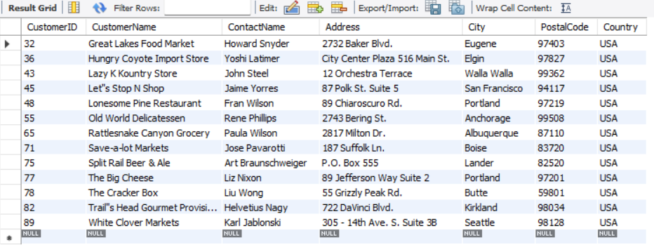

1. **Create view cust by selecting only 4 attributes from customers**

**Query:**

CREATE VIEW cust AS

SELECT CustomerID, CustomerName, ContactName, Country FROM customers;

SELECT * FROM sulavlab6.cust;

**Output:**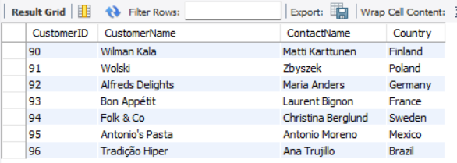

1. **Join Products with Categories and Suppliers to create a view named productinfo with ID,Name,Unit, Price from products and all attributes from categories and suppliers**

**Query:**

CREATE VIEW productinfo AS

SELECT

p.ProductID AS ID,

p.ProductName AS Name,

p.Unit,

p.Price,

c.*,

s.*

FROM

products p

JOIN

categories c ON p.CategoryID = c.CategoryID

JOIN

suppliers s ON p.SupplierID = s.SupplierID;

SELECT * FROM sulavlab6.productinfo;

**Output:**

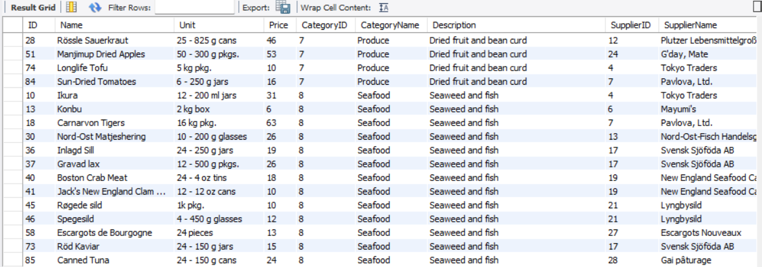

1. **Find name and count of Categories from productinfo**

**Query:**

SELECT CategoryName, COUNT(*) AS CategoryCount

FROM productinfo

GROUP BY CategoryName;

**Output:**

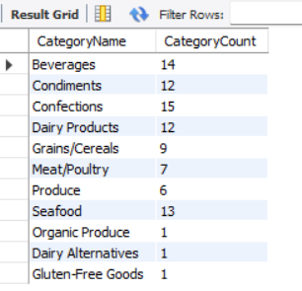

1. **Find all products that have suppliers from Asia in productinfo**

**Query:**

SELECT * FROM productinfo

WHERE Country IN ('China', 'India', 'Japan', 'South Korea', 'Thailand', 'Vietnam');

**Output:**

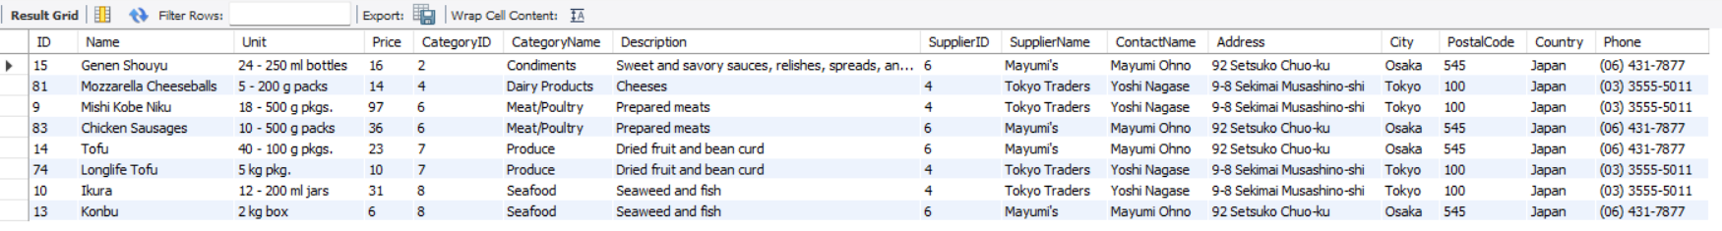

1. **Find all products that have price lower price than Average price from productinfo**

**Query:**

SELECT * FROM productinfo

WHERE Price < (SELECT AVG(Price) FROM productinfo);

**Output:**

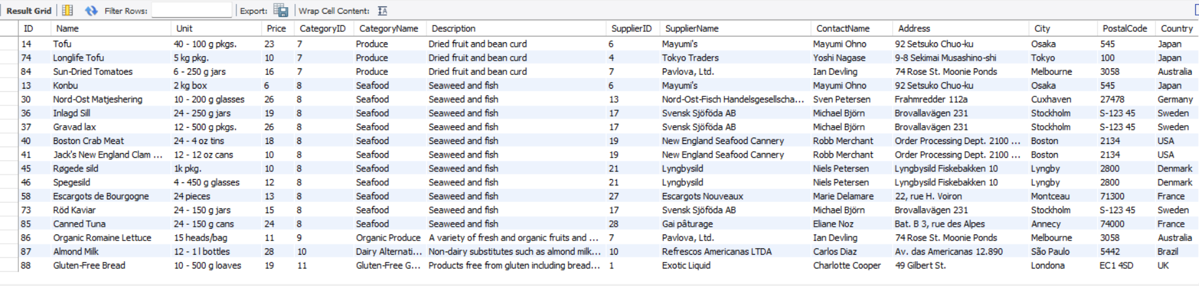

1. **Join orders with customers, employees and shippers to create a view as orderinfo**

**Query:**

CREATE VIEW orderinfo AS

SELECT

o.OrderID,

o.OrderDate,

c.CustomerName,

e.FirstName,

e.LastName,

s.ShipperName

FROM

orders o

JOIN

customers c ON o.CustomerID = c.CustomerID

JOIN

employees e ON o.EmployeeID = e.EmployeeID

JOIN

shippers s ON o.ShipperID = s.ShipperID;

SELECT * FROM sulavlab6.productinfo;

**Output:**

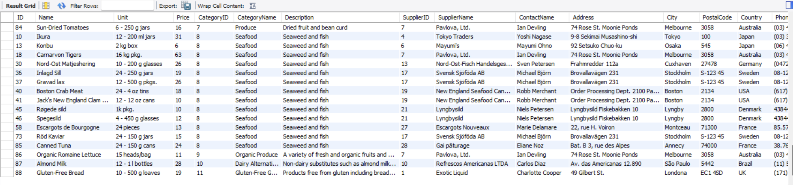

1. **List all order shipment provided by Speedy Express and Global Express from orderinfo**

**Query:**

SELECT * FROM orderinfo

WHERE ShipperName IN ('Speedy Express', 'Global Express');

**Output:**

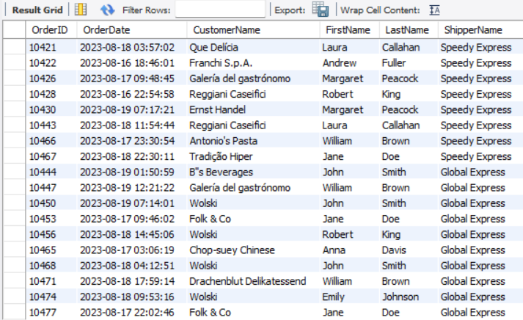

1. **List all order processed by employee Nancy Davolio and Michael Suyama from orderinfo**

**Query:**

SELECT * FROM orderinfo

WHERE (FirstName = 'Nancy' AND LastName = 'Davolio')

OR (FirstName = 'Michael' AND LastName = 'Suyama');

**Output:**

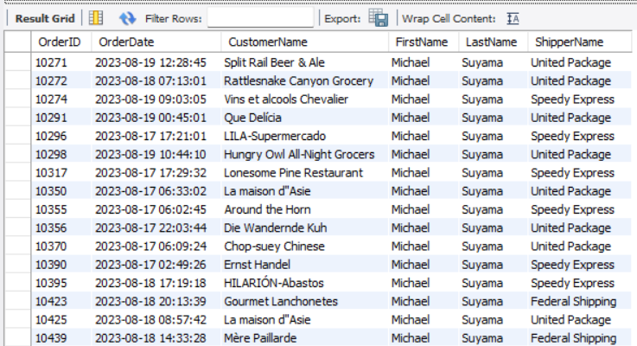

1. **List all order shipment provider on date august 19 2023 from orderinfo**

**Query:**

SELECT * FROM ORDERINFO WHERE ORDERDATE = '2023-08-19';

**Output:**

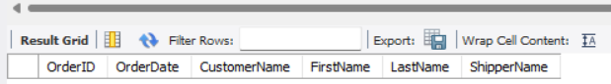

1. **List countries of customers that placed order on august 17 2023 from orderinfo**

**Query:**

SELECT DISTINCT C.COUNTRY

FROM ORDERS O

JOIN CUSTOMERS C ON O.CUSTOMERID = C.CUSTOMERID

WHERE O.ORDERDATE = '2023-08-17';

**Output:**

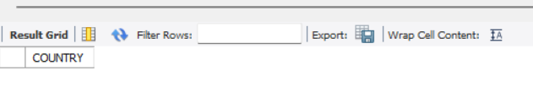

**Conclusion:**

Through the execution of the SQL queries, we successfully retrieved and organized data to meet the specified requirements. The use of UNION operations and joins enabled the extraction of data from multiple sources, providing a comprehensive view of the database's information. Overall, this exercise reinforced key SQL concepts, demonstrating the power of relational databases in managing and analyzing complex datasets.